**Software Architecture: One-Tier, Two-Tier, Three Tier, N Tier**

Software Architecture: Software Architecture consists of One Tier, Two Tier, Three Tier and N-Tier architectures.

A “tier” can also be referred to as a “layer”.

Three layers involved in the application namely Presentation Layer, Business Layer and Data Layer. Let’s see each layer in detail:

**Presentation Layer:** It is also known as Client layer. Top most layer of an application. This is the layer we see when we use a software. By using this layer we can access the webpages. The main functionality of this layer is to communicate with Application layer. This layer passes the information which is given by the user in terms of keyboard actions, mouse clicks to the Application Layer.  
For example, login page of Gmail where an end user could see text boxes and buttons to enter user id, password and to click on sign-in.

**Application Layer:** It is also known as Business Logic Layer which is also known as logical layer. As per the gmail login page example, once user clicks on the login button, Application layer interacts with Database layer and sends required information to the Presentation layer. It controls an application’s functionality by performing detailed processing. This layer acts as a mediator between the Presentation and the Database layer. Complete business logic will be written in this layer.

In a simple words, it is to perform operations on the application.

**Data Layer:** The data is stored in this layer. Application layer communicates with Database layer to retrieve the data. It contains methods that connects the database and performs required action e.g.: insert, update, delete etc.

In a simple words, it is to share and retrieve the data.

Must Read: [Manual Testing Complete Tutorial](https://www.softwaretestingmaterial.com/manual-testing-tutorial/)

## ****Types of Software Architecture:****

### ****One Tier Architecture:****

One Tier application AKA Standalone application

[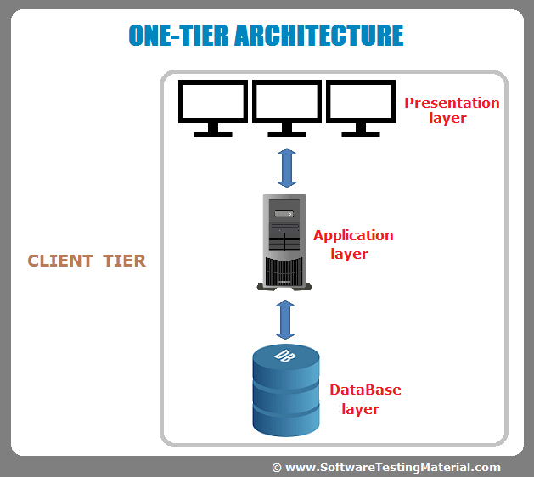](https://i0.wp.com/www.softwaretestingmaterial.com/wp-content/uploads/2016/06/one-tier-software-architecture.png?ssl=1)

One tier architecture has all the layers such as Presentation, Business, Data Access layers in a single software package. Applications which handles all the three tiers such as MP3 player, MS Office are come under one tier application. The data is stored in the local system or a shared drive.

### ****Two-Tier Architecture:****

Two Tier application AKA Client-Server application

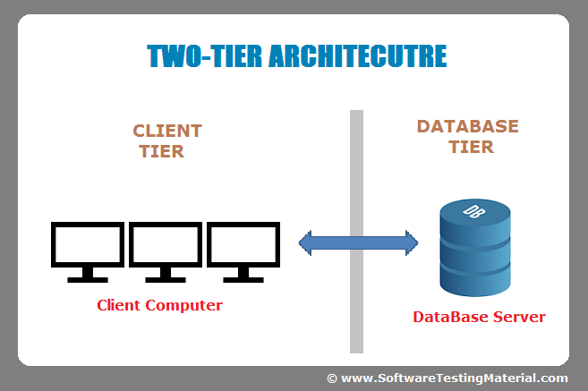

The Two-tier architecture is divided into two parts:

1. Client Application (Client Tier)  
2. Database (Data Tier)

Client system handles both Presentation and Application layers and Server system handles Database layer. It is also known as client server application. The communication takes place between the Client and the Server. Client system sends the request to the Server system and the Server system processes the request and sends back the data to the Client System

Must Read: [SQL for Software Testers Complete Tutorial](https://www.softwaretestingmaterial.com/sql-tutorial-complete/)

### ****Three-Tier Architecture:****

Three Tier application AKA Web Based application

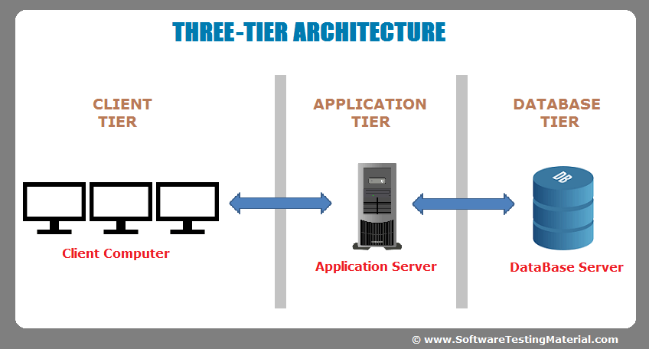

The Three-tier architecture is divided into three parts:

1. Presentation layer (Client Tier)  
2. Application layer (Business Tier)  
2. Database layer (Data Tier)

Client system handles Presentation layer, Application server handles Application layer and Server system handles Database layer.

**Note:** Another layer is N-Tier application. N-Tier application AKA Distributed application. It is similar to three tier architecture but number of application servers are increased and represented in individual tiers in order to distributed the business logic so that the logic will be distributed.